**Lesson 6 Demo 6**

**Configuration of Ingress**



Steps to be followed:

1. Creating a minimal Ingress configuration

**Step 1: Creating a minimal Ingress configuration**

* 1. Create a minimal ingress configuration file using the following command:

***vi miningress.yaml***



* 1. Add the following code to the configuration file:

***apiVersion: networking.k8s.io/v1***

***kind: Ingress***

***metadata:***

***name: minimal-ingress***

***annotations:***

***nginx.ingress.kubernetes.io/rewrite-target: /***

***spec:***

***rules:***

***- http:***

***paths:***

***- path: /testpath***

***pathType: Prefix***

***backend:***

***service:***

***name: test***

***port:***

***number: 80***

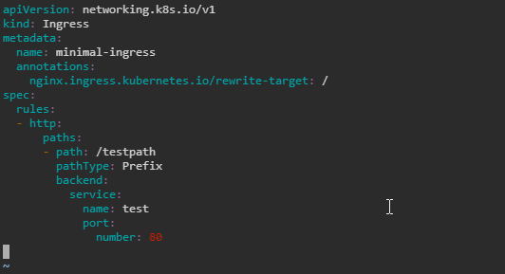

* 1. Create a resource for minimal Ingress using the following command:

***kubectl apply -f miningress.yaml***



* 1. Use the following command to check the created Ingress:

***kubectl get ingress -o wide***

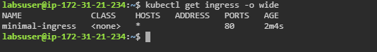

* 1. Describe the ingress using the following command:

***kubectl describe ingress minimal-ingress***

